Decorative board-up in New Jersey

Christopher B. Toepfer, Executive Director, ctoepfer@tnfamerica.com
www.tnfamerica.com 312-863-9111
The Neighborhood Foundation, NFP

Decorative board-up is a powerful tool for neighborhood revitalization and economic development. It addresses the core challenge of many cities face today: how to attract new residents and business to a city callenged with large numbers of vacant and abandoned buildings.

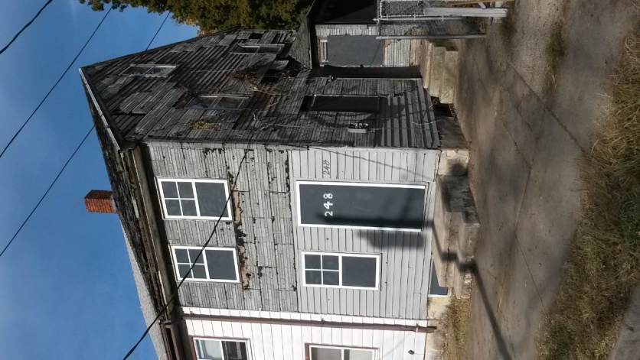
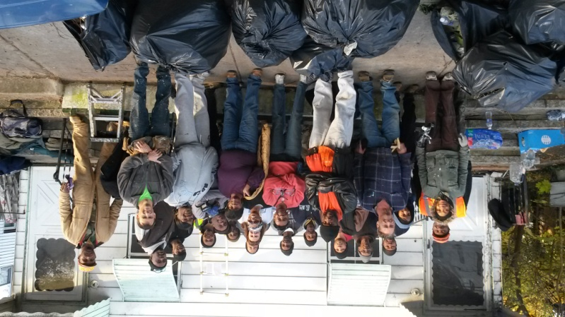

Stand Up for Salem Crew
Salem, New Jersey

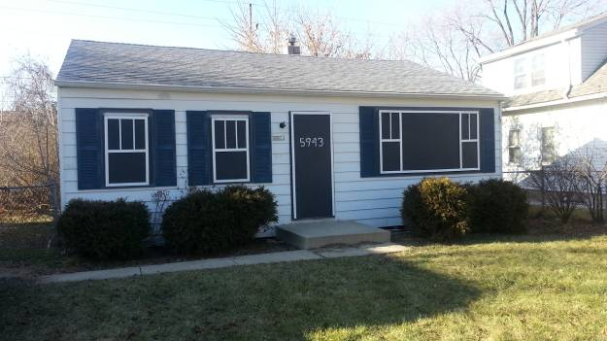
Examples of decorative board up in Salem

Example of decorative board up on a residential home in Milwaukee, WI
Example of decorative board up of multiunit buildings in Chicago, IL

